O’Sensei Richard Kim was a renowned martial artist, widely respected for his profound contributions to the world of martial arts. Born in Papaaloa, Hawaii in 1917, his journey into the world of martial arts began at the age of five years old, when his mother enrolled him in judo lessons under Tatsu Bata, believing that martial arts were the best way for one to learn respect for others.

During the 1930’s, O’Sensei Kim trained in boxing, and was a sparring partner to the 1930 world champion, Midget Wolgast. He would go on to have 42 professional fights, with a record of 42 wins / 0 losses. Simultaneously, he studied Karate under Sadao Arakaki, Tachibana, Higashionna, and Mizuho in Hawaii.

In 1935, he took a job with the merchant marines, which afforded him the opportunity to travel the orient and study with many famous masters of the time. It was during this time that he began delving deeply into the philosophical aspects of Karate, as well as its practical applications. In 1936, he graduated from the Budo Semmon Gaku, a martial arts specialty college in Japan. This was a special section of the Dai Nippon Butoku-Kai that required the mastery of 18 different martial arts to graduate.

During World War II, O’Sensei Kim spent time in Shang Hai, which gave him the opportunity to study the Chinese internal systems with Chen Chin Wan (Tai Chi Chuan), Chao Hsu Lie (Pa Kua), and Wang Xiang Zhay (Yi Chuan). He attended both St. John’s and Tung Wen College; studying languages and the art of investigation. He would go on to receive a Ph. D in political science from St. John’s University.
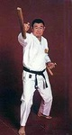
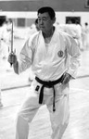
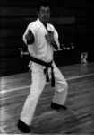
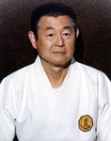
In the late 1940s, Kim moved to Japan, where he continued his martial arts training and immersed himself in the culture and traditions of the country. It was during this time that he met and trained with many of the great Japanese masters of the time: Sawai, Oyama, Kotaro, Ueshiba, Minatoya, Kinjo, Yamaguchi, Kanken, and Ohno Kumao.

Though O’Sensei Kim studied with many martial arts masters, it was Yoshida Kotaro that he considered to be his primary Sensei. Yoshida awarded him with the Menkyo Kaiden (a certificate of full proficiency given by a master to a chosen student best suited to carry on the style) in Daito Ryu in 1952.

In 1959, Kim moved permanently to San Francisco, and in the years that followed, he became one of the pioneering figures in introducing Karate to the western world. He would go on to travel extensively, teaching seminars and spreading the knowledge of Karate in the United States and Europe. His teachings were not limited to the physical techniques of Karate but also encompassed its spiritual and philosophical dimensions.

O’Sensei Kim founded the Zen Bei Butoku-Kai International, an organization dedicated to the promotion and preservation of traditional martial arts. Under his leadership, the ZBBKI became a prominent institution, fostering the growth of karate and other martial arts disciplines worldwide.
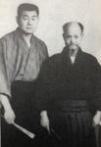
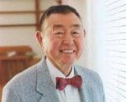
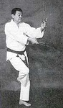
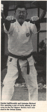
Throughout his life, O’Sensei Kim authored numerous books and articles on martial arts, sharing his insights and experiences with practitioners around the globe. From 1971 to 1974, he wrote a regular monthly column in “Karate Illustrated Magazine” called “The Classical Man” which featured short stories about Japanese martial artists. His writings often delved into the philosophical underpinnings of martial arts, exploring themes of discipline, respect, and self-improvement.

In 1967, he was voted “Sensei of the year” by Black Belt Magazine, and in the following year became the director of the IAKF US Team. He was the official weapons teacher to the JKA from the 1970s to the 1990s.

O’Sensei Kim passed away on November 8th, 2001 at the age of 83, but his legacy continues to inspire martial artists to this day. His organization, the Zen Bei Butoku-Kai International continues to thrive, under the guidance of Sensei Brian Ricci, Kim’s senior-most student at the time of his passing. The Zen Bei Butoku-Kai is dedicated to advancing the study of traditional Karate, Tai Chi Chuan, Chi Gong, Aiki-Jujitsu and Budo, and to foster the growth of these martial arts.

O’Sensei Kim’s dedication to the art of Karate, coupled with his deep understanding of its principles, has left an indelible mark on the martial arts community, ensuring that his contributions will be remembered and cherished for generations to come.

